**1. Login and Access Settings**

* After logging into the system, navigate to the **Chatbot** section.
* Locate the **Settings** option. This allows you to configure various aspects of the chatbot’s behaviour and appearance.

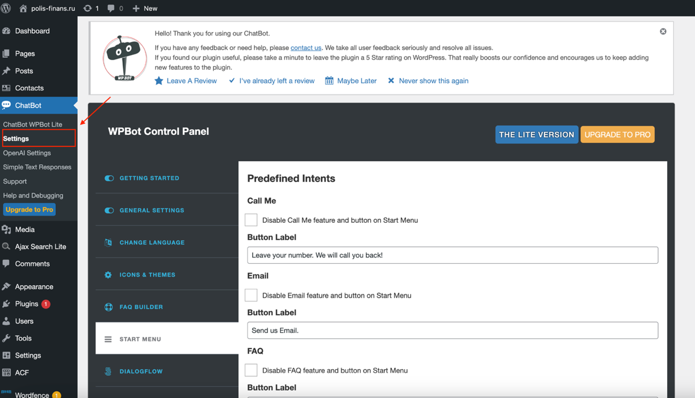

**2. Updating Email Address for queries received via chatbot**

* To change the email address associated with the chatbot, go to the **Settings** page.
* A screenshot of a email

  Description automatically generatedLocate the **General Settings** section. You can update the email address used for receiving inquiries via the chatbot, as well as the address from which inquiry responses will be sent. (might appear in junk sometimes)

**3. Customising Initial Greeting and Common Phrases**

* You can personalise the chatbot’s responses by modifying the messages.
* Under the **Change Language** section, input your custom greeting. This message will be displayed when a user interacts with the chatbot for the first time.
* Customise **Commonly Occurring Phrases** to match the tone or branding of your website or service. These include phrases frequently used during user interactions.

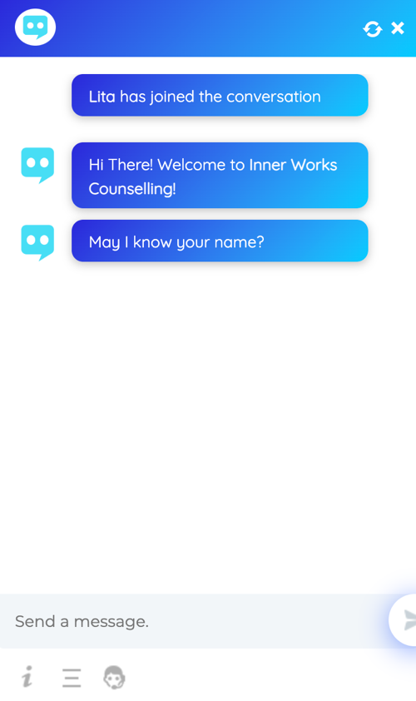

**4. Personalising the Chatbot Icon and Themes**

* In the **Icon & Themes**, you can change the visual representation of your chatbot.

**5. Building and Customising an FAQ Section**

* The **FAQ Builder** allows you to create a tailored list of frequently asked questions for the chatbot.
* 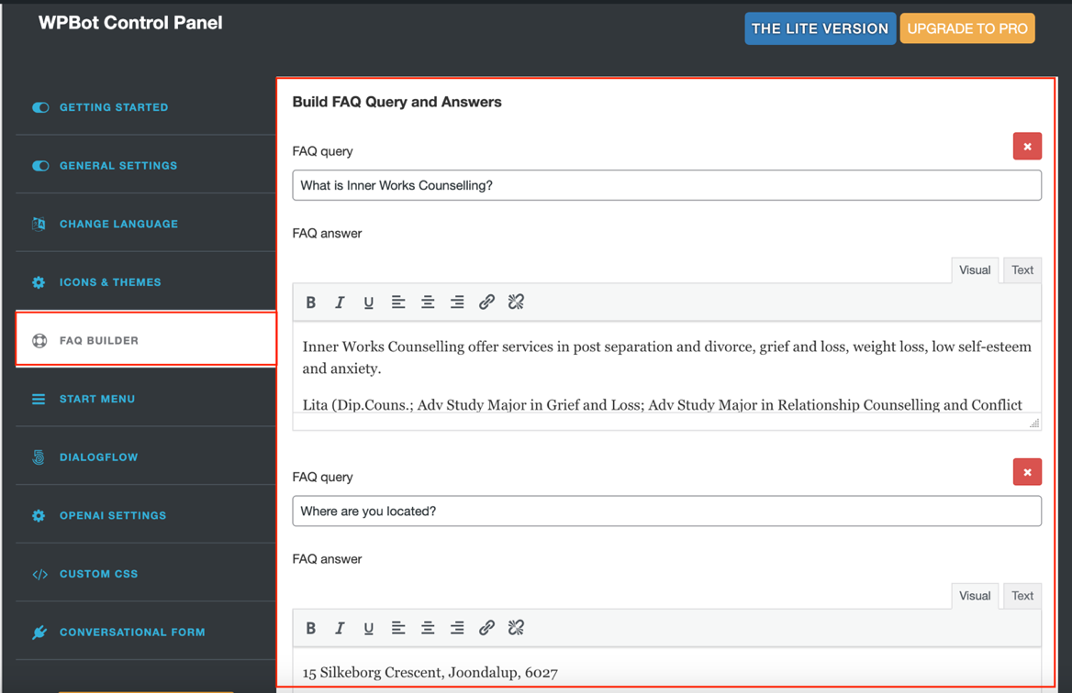Scroll down to the bottom of the **FAQ Section** to add more questions and answers.

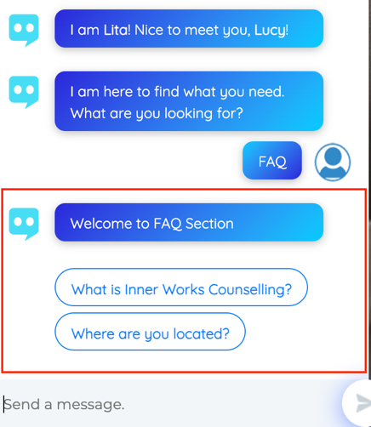

What the display appears as.